- INTRODUCTION

1. INTRODUCTION
In recent years, the volume of visual data collected through military surveillance, reconnaissance, and tactical operations has increased exponentially. According to defence technology reports, modern military operations generate terabytes of imagery and video data daily from drones, satellites, and field devices. Yet, more than 80% of this valuable data remains unstructured and unanalysed due to limited processing capabilities and lack of advanced automated tools. This creates a huge gap between data collection and actionable intelligence, affecting critical decisions on the ground. Traditional manual analysis of images and videos in military operations is not only time-consuming but also prone to human error and fatigue. Studies indicate that human analysts have a recognition accuracy of around 65–75% under high-stress environments, which can compromise mission success and troop safety. Leveraging machine learning and artificial intelligence is becoming a necessity to improve situational awareness, automate target recognition, and classify tactical scenarios accurately and reliably in near-real time.
With the advancement of computing hardware, open-source machine learning frameworks, and better data storage facilities, the defence sector is moving toward data-driven decision support systems. These systems can integrate historical data with real-time imagery to create a more comprehensive operational picture. As a result, military forces are seeking to adopt data-centric approaches to complement traditional methods, thereby transforming tactical decision-making into a faster, more reliable, and evidence-based process.

1.1 PROJECT PURPOSE
The purpose of this project is to develop an intelligent machine learning–based Tactical Decision Support System that can automatically classify military equipment from image data. Modern military operations generate a massive amount of visual data from drones, satellites, and surveillance systems, which is difficult and time-consuming for human analysts to process manually. This project aims to reduce human effort and errors by using machine learning and deep learning models to analyse and classify military images quickly and accurately, enabling faster and more reliable tactical decision-making.
Another important purpose of the project is to create a scalable and user-friendly system that integrates data preprocessing, model training, evaluation, and prediction within a graphical interface. By using models such as Perceptron, Deep Neural Networks (DNN), and a hybrid CNN-LSTM architecture, the system compares different algorithms and identifies the most effective approach for military image classification. This automated approach improves situational awareness, supports real-time decision support, and provides a foundation for future AI-based defence technologies.

1.2 PROJECT FEATURES
The project provides an intelligent system that can automatically classify military equipment from image data using machine learning and deep learning techniques. It processes images collected from different sources and converts them into a standardized format through image preprocessing. The images are resized, normalized, and converted into structured data so that they can be efficiently used for training machine learning models.
The system supports multiple algorithms for classification, including traditional machine learning models such as Perceptron and Decision Tree, as well as advanced deep learning models like Deep Neural Networks (DNN) and a hybrid CNN-LSTM architecture. These models are trained and evaluated using standard performance metrics such as accuracy, precision, recall, and F1-score. This allows comparison of different algorithms to identify the most effective model for military image classification.
Another important feature of the project is the graphical user interface developed using Tkin ter. The interface allows administrators to upload datasets, perform preprocessing, train models, and analyse performance results easily. Regular users can upload a new image and receive real-time predictions of the classified military equipment, making the system simple to use even for non-technical operators.
The project also includes secure authentication and role-based access control, separating administrator and user functionalities. Trained models and datasets are stored locally to ensure data confidentiality and faster access during prediction. The system also generates visual outputs such as confusion matrices and performance graphs, helping users understand the results clearly and supporting faster tactical decision-making.

2. LITERATURE SURVEY

2. LITERATURE SURVEY
Recent research highlights the growing role of machine learning and artificial intelligence in improving military decision-making systems. Traditional battlefield intelligence systems relied heavily on manual analysis and rule-based software, which limited their ability to process large volumes of data. With the increase in surveillance technologies such as drones and satellites, enormous amounts of visual information are generated daily. Researchers have therefore focused on developing intelligent systems capable of automatically analysing military data. Machine learning algorithms can detect patterns, classify objects, and support real-time tactical decisions. These capabilities make AI-based decision support systems highly valuable in modern defence operations.
Zigulic et al. studied the use of deep learning models for military object detection using visual datasets. Their work applied the YOLOv5 algorithm to detect military insignia and objects from video and image data. The researchers evaluated the model using metrics such as precision, recall, mAP, and F1-score. Their results showed that the model trained with Stochastic Gradient Descent performed significantly better than the one using the Adam optimizer. The high accuracy demonstrated that deep learning models can effectively recognize military objects across various terrains and conditions. This study highlights the potential of computer vision techniques in defence surveillance.

Costa et al. examined the use of machine learning in Beyond Visual Range (BVR) air combat simulations. Their research explored how AI techniques can improve threat detection, tactical behavior analysis, and pilot training environments. The authors emphasized the importance of simulation tools in testing decision-making strategies before real deployment. Machine learning allows adaptive tactical responses by analysing combat patterns and predicting enemy behavior. The study also identified several challenges in building realistic simulation environments. Overall, the research shows that AI-driven simulations can enhance decision-making efficiency in air combat scenarios.

Bistron et al. presented a comprehensive overview of artificial intelligence applications in both civilian and military sectors. Their research focused on areas such as cybersecurity, robotics, logistics, and object detection. The authors discussed several machine learning algorithms including CNN, SVM, and Gaussian Mixture Models. They explained how these algorithms help solve complex problems such as threat identification and security monitoring. The study also examined the social and ethical concerns related to the use of AI in military systems. Ethical responsibility and accountability remain key issues when autonomous systems are deployed.

Galán et al. conducted a bibliometric study to analyse the development of machine learning research in military organizations. Their work examined scientific publications related to AI-driven decision support systems. Using data mining and visualization tools, the authors identified key research areas and trends. The results revealed that machine learning has become an important technology for analysing large defence datasets. The study proposed a conceptual architecture for applying machine learning within military institutions. This research provides valuable insight into the future direction of AI-based military systems.

Skarka et al. explored the integration of machine learning and reinforcement learning techniques for autonomous navigation of unmanned aerial vehicles (UAVs). Their research focused on obstacle avoidance and real-time decision-making during flight operations. Reinforcement learning algorithms allow UAVs to learn optimal navigation strategies through interaction with their environment. The authors also analysed the limitations of current approaches and suggested improvements. Their study indicates that combining robotics with AI can significantly improve UAV autonomy. Such intelligent systems are highly useful in military surveillance and reconnaissance missions.

Alcántara Suárez et al. analysed the impact of machine learning on the defence sector and its broader implications. Their research discussed applications such as surveillance, target detection, and autonomous weapons systems. While the benefits of AI are significant, the authors also highlighted ethical concerns such as bias, accountability, and data privacy. They recommended greater transparency and regulatory frameworks to ensure responsible AI deployment.

2.1 REVIEW OF RELATED WORK
The field of tactical decision support systems has gained significant attention with the advancement of artificial intelligence, machine learning, and deep learning technologies. Researchers have explored various approaches to improve military decision-making, surveillance, and object detection using intelligent algorithms.
1. Artificial Intelligence for Military Object Detection
Research conducted by Zigulic et al. focused on the use of artificial intelligence for detecting military objects using the YOLOv5 object detection algorithm. Their study demonstrated that deep learning models could accurately identify military insignia and objects from images and videos. The model achieved high precision and recall values, showing that AI-based detection systems can perform effectively across different terrains and environments. The research also suggested that such models could be integrated into unmanned aerial vehicles to enable real-time detection and monitoring during military operations.
2. Machine Learning in Combat Simulation and Tactical Analysis
Costa et al. presented a comprehensive study on the use of machine learning and simulation techniques in beyond-visual-range (BVR) air combat scenarios. Their research explained how machine learning algorithms can analyse combat situations, predict enemy actions, and assist in tactical planning. Simulation environments were used to model realistic combat situations, enabling researchers to evaluate decision-making strategies and improve pilot training. The study highlighted that integrating machine learning with simulation tools can significantly enhance situational awareness and tactical coordination.
3. AI Applications in Defence and Security
Bistron et al. examined the broader applications of artificial intelligence in defence sectors, including cybersecurity, logistics, robotics, and object detection. Their research discussed several machine learning algorithms such as convolutional neural networks, support vector machines, and Gaussian mixture models. The study emphasized that AI technologies can improve efficiency, automate complex tasks, and support intelligent decision-making in military environments. However, it also highlighted ethical concerns and responsibility issues related to the use of autonomous systems in defence applications.
4. Hybrid Machine Learning Models for Image Classification
Karna et al. proposed a hybrid machine learning approach for classifying maritime vessel images. Their model used the Inception V3 deep learning architecture for feature extraction combined with traditional machine learning algorithms such as SVM, k-nearest neighbours, and logistic regression for classification. The study demonstrated that hybrid models can achieve high classification accuracy while maintaining computational efficiency. This research provides useful insights for developing intelligent image classification systems that combine deep learning with conventional machine learning techniques.
The review of related work shows that artificial intelligence and machine learning techniques play an important role in improving military surveillance and decision-making systems. Many researchers have successfully applied deep learning models for object detection, image classification, and tactical analysis. These studies highlight the effectiveness of automated systems in processing large amounts of visual data with high accuracy. They also demonstrate the potential of integrating AI with simulation and defence technologies.
2.2 DEFINITION OF PROBLEM STATEMENT
The problem addressed in this project is the difficulty of manually analysing large volumes of military image data collected from surveillance systems, drones, and satellites. Human analysis is time-consuming and can lead to errors or delays in identifying critical military equipment.

2.3 EXISTING SYSTEM
In traditional military tactical decision-making systems, intelligence gathering and analysis are largely manual or semi-automated. Analysts review raw image data obtained from aerial drones, satellite feeds, and ground-level sensors. These images are interpreted using prior knowledge, reference manuals, and domain experience. The insights derived are then compiled into tactical reports, which are shared with commanders and operational units for action. Such systems typically rely on legacy GIS (Geographic Information System) tools, manual tagging, and heuristic-based rules for classifying targets and threats. Intelligence officers use physical markers or static databases to compare features in imagery. The data pipeline is often linear — starting from image acquisition, followed by human inspection, and ending in text-based reporting. Communication between components is minimal, and there is little or no provision for learning from historical data.
Furthermore, these systems are not designed to handle real-time streams or adapt to new threat patterns. They lack automation in decision support, do not scale with increasing data loads, and have limited integration with AI or machine learning models. As a result, the efficiency and effectiveness of such systems in modern fast-paced combat environments are significantly compromised.
Limitations of Traditional System
- High dependency on human experts for analysing images, leading to delays in critical situations.
- Susceptible to human fatigue, error, and subjective interpretation, especially in prolonged missions.
- Inability to process large-scale datasets or real-time visual feeds effectively.
- Lack of learning mechanism — the system does not improve or adapt with experience.
- Non-scalable infrastructure that struggles with increasing image resolutions and volumes.
- Limited integration with advanced algorithms or predictive modelling tools.
- Weak support for cross-modal data fusion (e.g., combining text, images, geolocation).
2.4 PROPOSED SYSTEM
The project presents an intelligent tactical decision support system that leverages machine learning and deep learning techniques to classify military vehicles from images. The primary aim is to transform raw visual data into actionable intelligence that can support real-time decisions in military operations. Traditional military systems rely heavily on manual image interpretation, which is time-consuming and error-prone. In contrast, this system automates the classification of military assets such as tanks, helicopters, and aircraft using advanced computer vision models, enabling faster and more accurate decision-making. The system is developed with a user-friendly graphical user interface (GUI) that separates the roles of administrators and end-users. Administrators are responsible for uploading datasets, preprocessing images, splitting the data for training and testing, and training various machine learning models. These models include traditional classifiers like Perceptron, deep learning-based DNNs, and a hybrid CNN-LSTM architecture. Users, on the other hand, can input unseen images to obtain real-time predictions and visual feedback on the classified military object. This modular separation enhances usability and ensures smooth interaction for different roles in military intelligence workflows.
Key functionalities include dataset preprocessing, model training, evaluation through detailed metrics (accuracy, precision, recall, F1-score, sensitivity, specificity), and graphical analysis of model performance. The system also supports prediction for new test images and visualizes classification results. By incorporating convolutional neural networks and recurrent neural networks, particularly LSTM layers, the hybrid model captures both spatial and temporal patterns in images, enhancing classification accuracy. Overall, the project offers a scalable, efficient, and intelligent platform to support tactical decisions in defence scenarios through automated military asset recognition.

ADVANTAGES OF PROPOSED SYSTEM
- The system automatically classifies military equipment from images, reducing the need for manual analysis.
- It improves accuracy and speed in identifying different types of military vehicles and aircraft.
- The system can process large volumes of image data efficiently.
- It supports faster and better tactical decision-making during military operations.
- The use of machine learning and deep learning models increases the reliability of predictions.
- The graphical user interface makes the system easy to use for both administrators and users.
- The system allows comparison of multiple algorithms to select the best performing model.
- The system reduces human workload by automating the process of analysing military images.
- It helps in early detection and identification of potential threats in surveillance data.
- The system provides visual performance analysis such as graphs and confusion matrices for better understanding of results.
- It is scalable and can be extended in the future to include more categories of military equipment and larger datasets.

2.5 OBJECTIVES
- Automated Military Equipment Classification
To develop a system that can automatically classify different types of military equipment such as tanks, helicopters, and aircraft using image data.
- Use of Machine Learning and Deep Learning Models
To implement and compare different algorithms such as Perceptron, Decision Tree, Deep Neural Networks (DNN), and CNN-LSTM for accurate image classification.
- Image Preprocessing and Data Preparation
To perform image preprocessing techniques such as resizing, normalization, and data conversion to prepare the dataset for model training.
- User-Friendly Graphical Interface
To design a graphical user interface that allows users to easily upload images, train models, and view prediction results.

2.6 HARDWARE & SOFTWARE REQUIREMENTS
2.6.1 SOFTWARE REQUIREMENTS
Software requirements specify the programs and tools needed to develop and operate the system. These include the operating system, programming languages such as Python, and libraries or frameworks used for machine learning and image processing. Proper software support helps in building, running, and maintaining the application successfully.
- Python : 3.7.6
- Operating system : Windows
- Frontend : Tkinter
2.6.2 HARWARE REQUIREMENTS
Hardware requirements specify the physical components needed to run the system effectively. This includes devices such as a computer or laptop with sufficient processor speed, RAM, and storage capacity to handle data processing and model training. Proper hardware ensures the system runs smoothly and performs tasks like image processing and prediction efficiently.
- Processor : Intel i3
- Memory : 500 GB (storage)
- RAM : 4 GB

3. SYSTEM
ARCHITECTURE &
DESIGN

3. SYSTEM ARCHITECTURE & DESIGN
The system architecture and design describe how different components of the project are organized and interact with each other. The system follows a structured workflow that includes image input, preprocessing, model training, and prediction. Images are first processed and converted into a suitable format before being used by machine learning and deep learning models. The trained models then classify the images into different categories of military equipment. The architecture also includes a graphical user interface that allows users to upload images, train models, and view the classification results easily.

3.1 PROJECT ARCHITECTURE
Project architecture defines the overall structure of the system and how different components interact with each other.
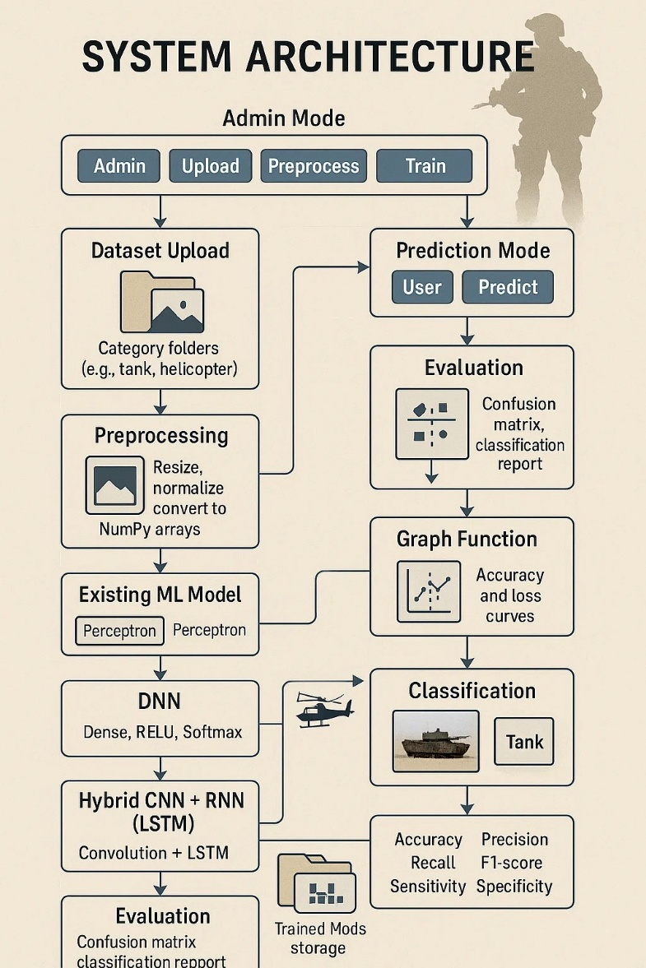
3.2 DESCRIPTION
Image Dataset Collection : The system collects a dataset of military equipment I mages used for training and testing the models.

Image Input : Users upload images to the system for processing and classification.

Image Preprocessing : Images are resized, normalized, and converted into a suitable format for machine learning models.
Feature Extraction : Important features are extracted from images to help the models understand patterns.
Model Training : Machine learning and deep learning models are trained using the prepared dataset.
Algorithm Implementation : Different algorithms such as Perceptron, Decision Tree, DNN, and CNN-LSTM are applied for classification.

Model Evaluation : The trained models are evaluated using metrics like accuracy, precision, recall, and F1-score.

Prediction Module : The system predicts the category of military equipment when a new image is uploaded.

User Interface : A graphical interface allows users to interact with the system easily.

Result Visualization : The system displays prediction results and performance graphs for better understanding.

3.3 UNIFIED MODELING LANGUAGE(UML)

Unified Modelling Language (UML) is not just a static set of diagrams; it's a versatile toolset that supports multiple views and perspectives of a system. This versatility allows UML to be applied at different stages of the software development lifecycle, from initial requirements analysis and design to implementation, testing, and maintenance.
UML diagrams serve as a common visual language that bridges the gap between technical and non-technical stakeholders. They provide a means for software engineers to communicate complex system designs in a clear and concise manner, facilitating better understanding and collaboration among team members.
One of the key benefits of UML is its adaptability to different software development methodologies, such as waterfall, agile, and iterative approaches. UML diagrams can be used to model systems at various levels of abstraction, from high-level architectural views to detailed design specifications.
Furthermore, UML is not limited to software systems alone; it can also be applied to model and analyse business processes, organizational structures, and even hardware systems. This flexibility makes UML a valuable tool for a wide range of industries and domains.

GOALS OF UML
- Provide users a ready-to-use, expressive visual modelling language so that they can develop and exchange meaningful models.
- Provide extendibility and specialization mechanisms to extend the core concepts.
- Be independent of particular programming languages and development processes.
- Provide a formal basis for understanding the modelling language.

3.3.1 USECASE DIAGRAM
A use case diagram in the Unified Modelling Language (UML) is a type of behavioural diagram defined by and created from a Use-case analysis. Its purpose is to present a graphical overview of the functionality provided by a system in terms of actors, their goals (represented as use cases), and any dependencies between those use cases. The main purpose of a use case diagram is to show what system functions are performed for which actor. Roles of the actors in the system can be depicted.

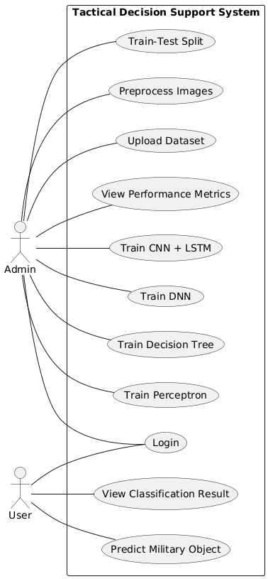
Figure 3.2 USE CASE DIAGRAM
3.3.2 CLASS DIAGRAM
In software engineering, a class diagram in the Unified Modelling Language (UML) is a type of static structure diagram that describes the structure of a system by showing the system's classes, their attributes, operations (or methods), and the relationships among the classes. It explains which class contains information.
A class diagram is a static structural diagram that represents the structure of a system by showing the system's classes, their attributes, methods, and relationships among them. It provides a high-level view of the system's architecture, focusing on the entities (classes) and their interactions. Class diagrams are typically used during the design phase of software development to visualize and organize the system's components and their relationships.

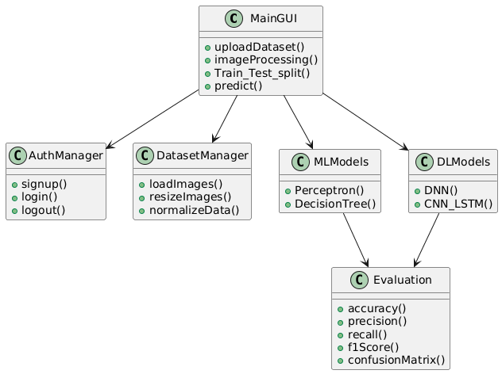
Figure 3.3 CLASS DIAGRAM

3.3.3 SEQUENCE DIAGRAM
A sequence diagram in Unified Modelling Language (UML) is a kind of interaction diagram that shows how processes operate with one another and in what order. It is a construct of a Message Sequence Chart. Sequence diagrams are sometimes called event diagrams, event scenarios, and timing diagrams.

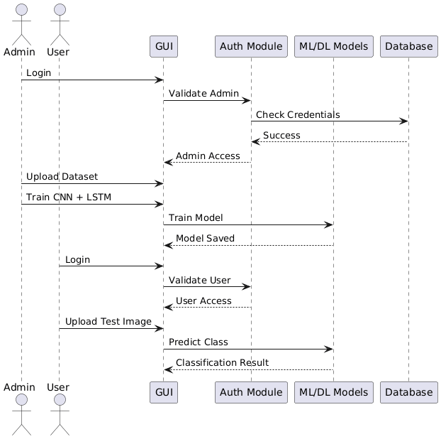

3.3.4 ACTIVITY DIAGRAM
An activity diagram visually represents the workflow of a system, showing the sequence of actions and decision points. In our project, it illustrates how a user performs actions such as uploading or downloading files within the simulated network environment. The system monitors the generated network traffic and processes the packet information using a MapReduce-based analysis mechanism to classify the traffic as normal or attack. The monitoring results are then displayed through a graphical dashboard, allowing users and administrators to observe the network behavior and analyze the security status of the system.

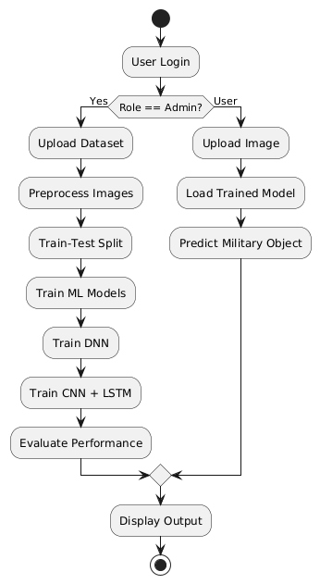

3.3.5 DATA FLOW DIAGRAM
A Data Flow Diagram (DFD) represents the flow of data within the system and shows how information moves between different processes. In this project, the DFD illustrates how image data is collected, processed, and classified using machine learning models. The process begins with the user uploading an image dataset, which is then sent to the preprocessing module where images are resized and normalized. After preprocessing, the data is passed to the model training and classification module where machine learning algorithms analyse the images and predict the type of military equipment. Finally, the system displays the classification results to the user through the graphical interface.
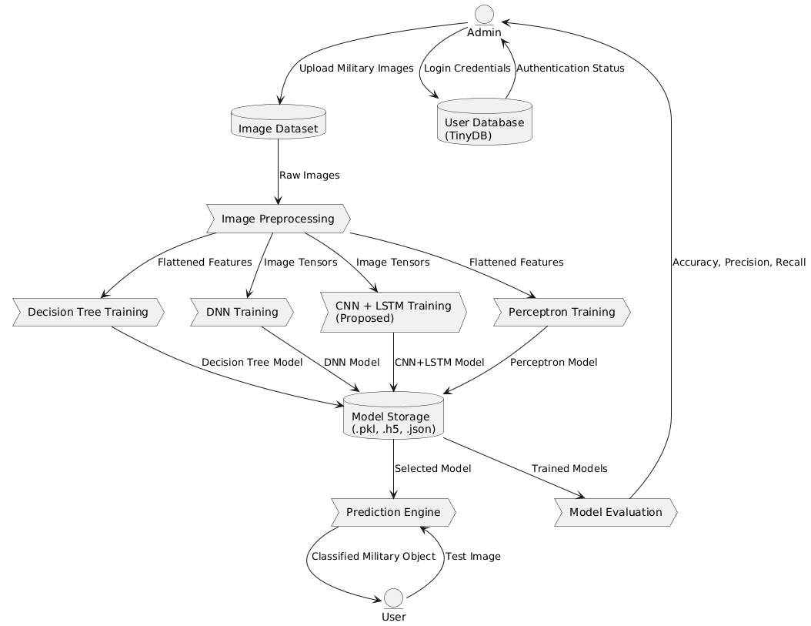

4. IMPLEMENTATION

4. IMPLEMENTATION
Implementation is the phase where the proposed system is developed and executed according to the design and architecture. In this project, the implementation involves building a machine learning–based system that can classify military equipment images. The system integrates image preprocessing, model training, and prediction modules using Python and related libraries. The graphical user interface is also implemented to allow users to upload images and view classification results easily.
4.2 ALGORITHMS USED
1. Perceptron Algorithm
The Perceptron is one of the earliest and simplest machine learning algorithms used for binary classification problems. It works by finding a linear boundary that separates data into different classes based on input features. The algorithm learns by adjusting weights during training whenever it makes a wrong prediction. In image classification tasks, perceptron can be used to identify simple patterns in processed image data. Although it is a basic model, it plays an important role in understanding how neural networks work. In this project, the perceptron algorithm is used as a baseline model to compare the performance of more advanced deep learning models.
Advantages
- Simple and easy to implement.
- Requires less computational power.
- Useful for understanding basic machine learning concepts.
Disadvantages
- Works only with linearly separable data.
- Not suitable for complex image classification tasks.
- Limited accuracy compared to deep learning models.

Why It Is Used in the Project?
The perceptron algorithm is used to provide a basic classification approach and to compare its performance with more advanced models. It helps demonstrate how simple machine learning models perform on military image classification tasks.
2. Decision Tree Algorithm
The Decision Tree algorithm is a supervised machine learning method used for classification and prediction tasks. It works by splitting the dataset into branches based on feature values, forming a tree-like structure where each node represents a decision rule. The algorithm continues dividing the data until it reaches a final decision or classification at the leaf nodes. Decision trees are easy to interpret because their structure visually represents the decision-making process. In image classification problems, decision trees analyse extracted features and determine the most probable class. In this project, the algorithm helps classify military equipment images based on learned feature patterns.
Advantages
- Easy to understand and interpret.
- Works well with both numerical and categorical data.
- Requires less data preparation.
Disadvantages
- Can easily overfit the training data.
- Performance may decrease with very large datasets.
- Not as powerful as deep learning models for complex image data.
Why It Is Used in the Project?
Decision trees are used because they provide interpretable classification results and help understand how different features influence the prediction of military equipment categories.

3. Deep Neural Network (DNN)
A Deep Neural Network is an advanced machine learning model inspired by the structure of the human brain. It consists of multiple layers of interconnected neurons that process data and learn complex patterns. Each layer extracts higher-level features from the input data, allowing the model to recognize complicated structures in images. DNNs are widely used in image classification, speech recognition, and many other artificial intelligence applications. In this project, the DNN model analyzes processed image features and learns patterns that distinguish different types of military equipment.
Advantages
- Can learn complex patterns from large datasets.
- Provides higher accuracy compared to simple models.
- Suitable for image recognition and classification.
Disadvantages
- Requires large datasets for effective training.
- High computational cost.
- Training can take longer time.
Why It Is Used in the Project?
The Deep Neural Network is used because it can learn complex visual pattern in military equipment images, leading to improved classification accuracy.
4. CNN–LSTM Hybrid Model
The CNN–LSTM hybrid model combines two powerful deep learning architectures: Convolutional Neural Networks (CNN) and Long Short-Term Memory (LSTM) networks. CNN is responsible for extracting spatial features from images, such as shapes, textures, and edges. LSTM networks are commonly used for sequential data and help capture relationships between extracted features. By combining these two models, the system can analyze both spatial patterns and feature dependencies more effectively. This hybrid approach improves classification performance and provides more accurate predictions. In this project, the CNN-LSTM model is used as the most advanced model for identifying different categories of military equipment.
Advantages
- Highly effective for image classification tasks.
- Captures complex spatial patterns in images.
- Provides higher prediction accuracy.
Disadvantages
- Requires high computational resources.
- More complex to implement.
- Training time is longer compared to simpler models.
Why It Is Used in the Project
The CNN-LSTM hybrid model is used because it combines the strengths of CNN and LSTM networks, allowing the system to achieve better performance in military equipment image classification.
In this project, multiple machine learning and deep learning algorithms are implemented to classify military equipment images accurately. Each algorithm plays a different role in analysing the dataset and learning patterns from the image data. The use of multiple algorithms allows the system to compare their performance and determine the most effective model for the classification task.
Traditional machine learning algorithms such as Perceptron and Decision Tree provide simple and interpretable approaches to classification. These models require less computational power and are easier to implement, making them useful for baseline comparisons. However, their ability to analyse complex image patterns is limited when compared to deep learning methods.
Deep learning models such as Deep Neural Networks and CNN-LSTM architectures are capable of extracting high-level features from images. These models use multiple layers to identify patterns such as shapes, textures, and structures within the images. Because of this ability, deep learning models generally achieve higher accuracy in image recognition tasks.
By implementing and comparing these algorithms, the project demonstrates how different machine learning techniques perform in military equipment classification. The evaluation results help determine which algorithm provides the best balance between accuracy, computational efficiency, and scalability. This approach ensures that the final tactical decision support system is both reliable and efficient in analysing image data for defence-related applications.
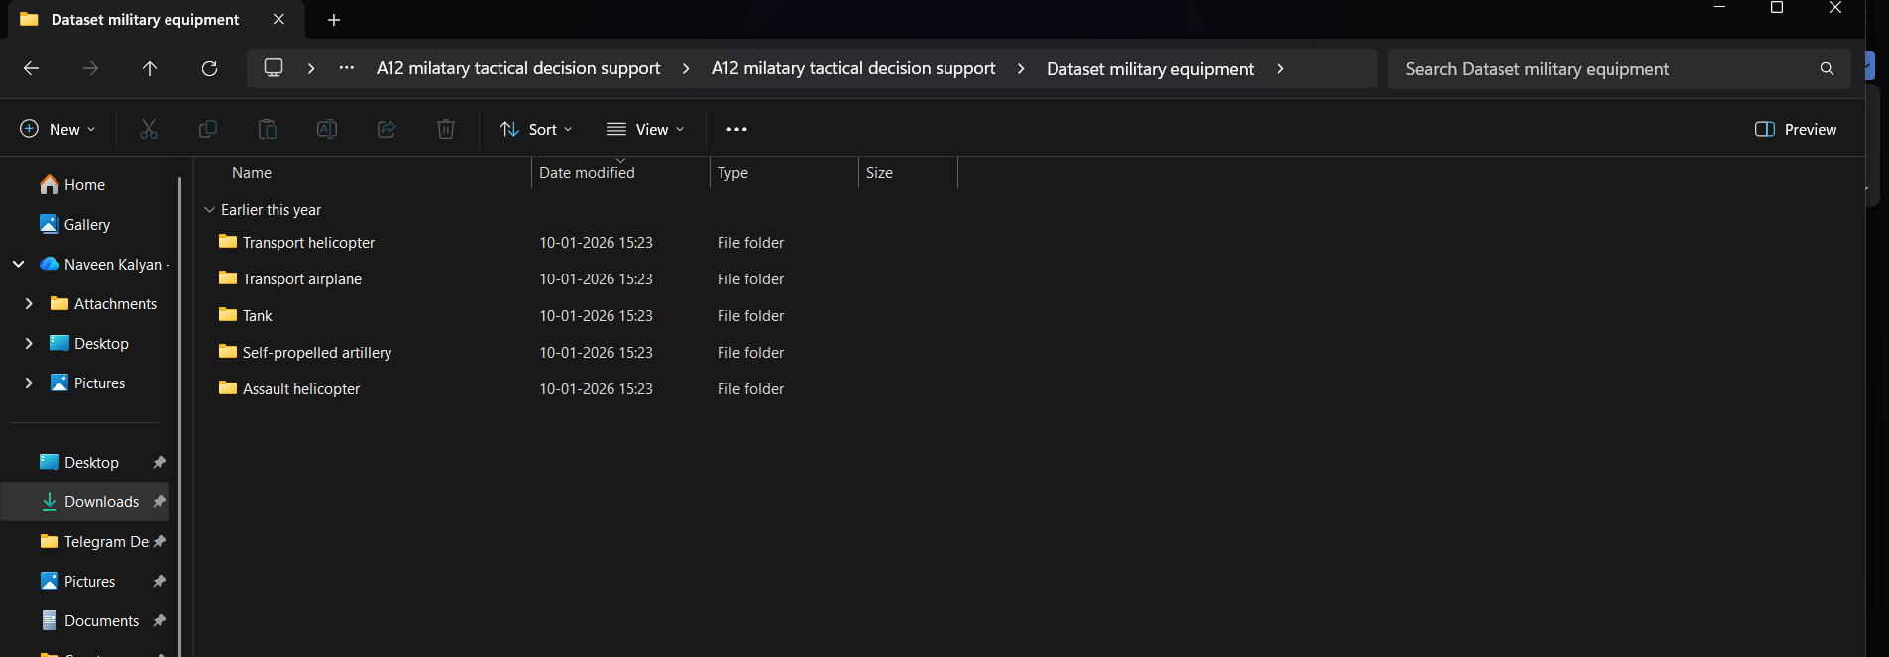
Figure 4.1 Dataset directory structure with folders Transport helicopter, transport airplane, tanks, self-propelled artillery, Assault helicopter having all the training examples
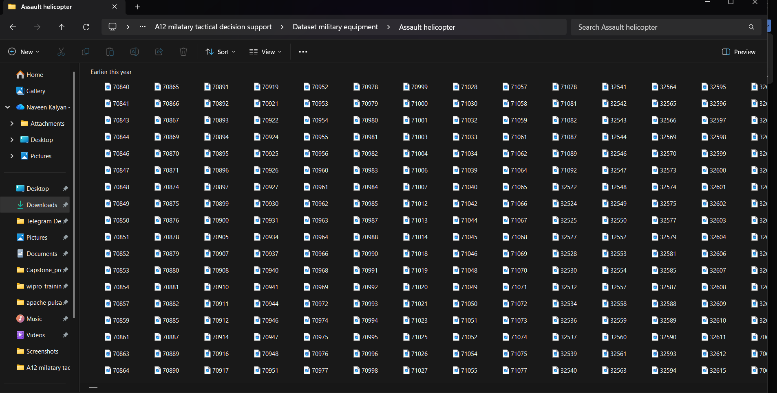
Figure 4.2 Screenshot of the “Assault helicopter” Folder showing sample image files

To implement this project, the system is divided into several modules that handle different tasks in the workflow.
1. Dataset Upload Module
This module allows the administrator to upload the military equipment image dataset into the system. The uploaded data is stored and prepared for further processing and model training.
2. Image Preprocessing Module
This module processes the uploaded images by resizing, normalizing, and converting them into a format suitable for machine learning models. It helps improve the quality of input data.
3. Model Training Module
In this module, machine learning and deep learning algorithms such as Perceptron, Decision Tree, DNN, and CNN-LSTM are trained using the prepared dataset.
4. Classification Module
This module classifies the uploaded images into different categories of military equipment using the trained models.
5. Prediction Module
It predicts the category of a new image uploaded by the user and displays the classification result.
6. User Interface Module
This module provides a graphical user interface that allows users to interact with the system, upload images, train models, and view results easily.
7. Model Evaluation Module
This module evaluates the performance of the trained models using metrics such as accuracy, precision, recall, and F1-score to determine how well the system performs.
8. Result Visualization Module
This module displays the classification results and performance graphs such as confusion matrices and accuracy charts for better understanding of the model performance.
9. Data Storage Module
This module manages the storage of datasets, trained models, and prediction results so that they can be accessed and used efficiently when require
4.2 SAMPLE CODE
from tkinter import messagebox
from tkinter import *
from tkinter import simpledialog
import tkinter
import warnings
warnings.filterwarnings('ignore')
import matplotlib.pyplot as plt
import numpy as np
from sklearn.tree import DecisionTreeClassifier
import pandas as pd
from tkinter import ttk
from tkinter import filedialog
from keras.utils.np_utils import to_categorical
from keras.models import Sequential
from keras.layers.core import Dense,Activation,Dropout, Flatten
from sklearn.metrics import accuracy_score
from sklearn.metrics import precision_score
from sklearn.metrics import recall_score
from sklearn.metrics import f1_score
from sklearn.metrics import classification_report
from sklearn.metrics import confusion_matrix
import seaborn as sns
import os
import hashlib
from tinydb import TinyDB, Query
import cv2
import joblib
from sklearn.ensemble import RandomForestClassifier
from sklearn.model_selection import train_test_split
from keras.layers import Convolution2D
from keras.layers import MaxPooling2D
import pickle
from keras.models import model_from_json
from skimage.transform import resize
from skimage.io import imread
from skimage import io, transform
from sklearn.neural_network import MLPClassifier
from sklearn.naive_bayes import MultinomialNB
from keras.models import Sequential, model_from_json
from keras.layers import Convolution2D, MaxPooling2D, Flatten, Dense, Reshape
global filename
global X, Y
global model
global categories,model_folder
model_folder = "model"
def uploadDataset():
global filename,categories
text.delete('1.0', END)
filename = filedialog.askdirectory(initialdir=".")
categories = [d for d in os.listdir(filename) if os.path.isdir(os.path.join(filename, d))]
text.insert(END,'Dataset loaded\n')
text.insert(END,"Classes found in dataset: "+str(categories)+"\n")
def imageProcessing():
text.delete('1.0', END)
global X, Y, model_folder, filename
X_file = os.path.join(model_folder, "X_compressed.npz")
Y_file = os.path.join(model_folder, "Y.npy")
if os.path.exists(X_file) and os.path.exists(Y_file):
X = np.load(X_file)['X'] # Load from compressed .npz
Y = np.load(Y_file)
else:
X = []
Y = []
for root, dirs, directory in os.walk(filename):
for j in range(len(directory)):
name = os.path.basename(root)
print(f'Loading category: {dirs}')
print(name + " " + os.path.join(root, directory[j]))
if 'Thumbs.db' not in directory[j]:

def login(role):
def verify_user():
username = username_entry.get()
password = password_entry.get()
if username and password:
hashed_password = hashlib.sha256(password.encode()).hexdigest()
User = Query()
result = users_table.search(
(User.username == username) &
(User.password == hashed_password) &
(User.role == role)
)
if result:
messagebox.showinfo("Success", f"{role} Login Successful!")
login_window.destroy()
clear_buttons()
if role == "Admin":
show_admin_buttons()
elif role == "User":
show_user_buttons()
else:
messagebox.showerror("Error", "Invalid Credentials!")
else:
messagebox.showerror("Error", "Please enter all fields!")
command=show_user_buttons,
font=font1,
bg='red').place(x=20, y=500)
tk.Button(main, text="Exit",
command=close,
font=font1).place(x=20, y=600)
tk.Button(main, text="Admin Signup", command=lambda: signup("Admin"), font=font1, width=20, height=1, bg='red').place(x=100, y=100)
tk.Button(main, text="User Signup", command=lambda: signup("User"), font=font1, width=20, height=1, bg='red').place(x=400, y=100)
tk.Button(main, text="Admin Login", command=lambda: login("Admin"), font=font1, width=20, height=1, bg='Lightpink').place(x=700, y=100)
tk.Button(main, text="User Login", command=lambda: login("User"), font=font1, width=20, height=1, bg='Lightpink').place(x=1000, y=100)
def close():
main.destroy()
main = tk.Tk()
screen_width = main.winfo_screenwidth()
screen_height = main.winfo_screenheight()
main.geometry(f"{screen_width}x{screen_height}")
import os
import joblib
import tkinter as tk
from tkinter import filedialog, Text, ttk
from PIL import Image, ImageTk
# Load Background Image
bg_image = Image.open("background.jpg")
bg_image = bg_image.resize((1380, 730), Image.LANCZOS)
bg_photo = ImageTk.PhotoImage(bg_image)
bg_label = tk.Label(main, image=bg_photo)
bg_label.place(relwidth=1, relheight=1)
# Configure title
font = ('times', 18, 'bold')
title_text = "Machine Learning for Tactical Decision Support: A Data-Driven Study of Military Scenarios"
title = tk.Label(main, text=title_text, bg='white', fg='black', font=font, height=3, width=120)
title.pack()
# Text area for displaying results or logs
text = tk.Text(main, height=15, width=70)
scroll = tk.Scrollbar(text)
text.configure(yscrollcommand=scroll.set)
text.place(x=50, y=180)
text.config(font= ('times', 12, 'bold'))

# ================= AUTHENTICATION BUTTONS =================
font_auth = ('times', 14, 'bold')
tk.Button(
main,
text="Admin Signup",
command=lambda: signup("Admin"),
font=font_auth,
width=20,
bg='red'
).place(x=150, y=100)
tk.Button(
main,
text="Admin Login",
command=lambda: login("Admin"),
font=font_auth,
width=20,
bg='LightPink'
).place(x=450, y=100)
tk.Button(
main,
text="User Signup",
command=lambda: signup("User"),
font=font_auth,
width=20,
).place(x=750, y=100)
tk.Button(
main,
text="User Login",
command=lambda: login("User"),
font=font_auth,
width=20,
bg='LightPink'
).place(x=1050, y=100)
def show_auth_buttons():
clear_buttons()
font_auth = ('times', 14, 'bold')
tk.Button(main, text="Admin Signup",
command=lambda: signup("Admin"),
font=font_auth, width=20, bg='red').place(x=150, y=100)
tk.Button(main, text="Admin Login",
command=lambda: login("Admin"),
font=font_auth, width=20, bg='LightPink').place(x=450, y=100)
tk.Button(main, text="User Signup",
command=lambda: signup("User"),
font=font_auth, width=20, bg='red').place(x=750, y=100)
tk.Button(main, text="User Login",
command=lambda: login("User"),
font=font_auth, width=20, bg='LightPink').place(x=1050, y=100)
main.config(bg='deep sky blue')
main.mainloop()

5. RESULTS &
DISCUSSIONS

5. RESULTS AND DISCUSSIONS
5.1 Implementation description
The implementation of the Machine Learning for Tactical Decision Support system is carried out using Python with an integrated Tkinter-based graphical user interface. The system begins with secure role-based authentication, allowing Admin users to upload military image datasets and perform preprocessing such as resizing, normalization, and data caching. The processed data is split into training and testing sets and used to train multiple models, including Perceptron, Decision Tree, Deep Neural Network, and the proposed hybrid CNN–LSTM architecture. Model performance is evaluated using standard metrics and visualized through confusion matrices and accuracy graphs. Trained models are stored locally for reuse, enabling users to upload individual images for real-time military object classification, with prediction results displayed visually to support effective tactical decision-making.
1. Importing Required Libraries
The implementation begins by importing essential Python libraries required for graphical user interface creation, image processing, machine learning, deep learning, visualization, and database handling. Libraries such as Tkinter manage the GUI, OpenCV handles image operations, Scikit-learn supports classical machine learning algorithms, and TensorFlow/Keras enables deep learning model development. Additional libraries like NumPy, Pandas, Matplotlib, Seaborn, and TinyDB support data handling, visualization, and secure user authentication.
2. Graphical User Interface Initialization
A full-screen Tkinter window is initialized to serve as the main application interface. The GUI is enhanced with a background image and a title banner to improve usability and presentation. A scrollable text area is configured to display system logs, training progress, and performance metrics dynamically during execution.
3. User Authentication and Role Management
The system implements role-based authentication using TinyDB for secure credential storage. Admin and User roles are defined, with passwords hashed using SHA-256 for security. Admin users are granted access to dataset management and model training functions, while User access is restricted to prediction and result visualization.
4. Dataset Upload and Class Detection
The Admin uploads a dataset directory through the GUI, where each subfolder represents a distinct military equipment class. The system automatically detects class names and displays them in the output console. This flexible structure allows the system to adapt to varying numbers of military object categories.
5. Image Preprocessing and Normalization
All images in the dataset are read using OpenCV and resized to a uniform resolution of 128×128 pixels. Pixel values are normalized to improve numerical stability during model training. The processed image data and corresponding labels are stored as NumPy arrays to ensure efficient computation.
6. Dataset Train-Test Splitting
The processed dataset is randomly shuffled to eliminate ordering bias. It is then split into training and testing subsets using an 80:20 ratio. This step ensures fair evaluation and helps measure the generalization capability of each learning algorithm.
7. Training the Perceptron Classifier (Existing Model)
The Perceptron classifier is trained using flattened image features to serve as a baseline machine learning model. The trained model is saved using Joblib to enable reuse without retraining. Its performance provides a reference for evaluating more advanced models.
8. Training the Decision Tree Classifier (Existing Model)
A Decision Tree classifier is trained on the same flattened feature vectors to capture nonlinear decision boundaries. The model is serialized and stored locally for future inference. This model helps analyze the effectiveness of tree-based approaches for military image classification.
9. Deep Neural Network (DNN) Implementation
A fully connected Deep Neural Network is implemented using Keras, consisting of a flatten layer followed by dense layers. The DNN is trained using categorical cross-entropy loss and Adam optimizer. Model architecture and weights are saved to support efficient reloading and evaluation.
10. Proposed CNN with LSTM Model Implementation
The proposed hybrid model integrates Convolutional Neural Networks for spatial feature extraction with an LSTM layer for capturing sequential dependencies. Multiple convolution and pooling layers extract hierarchical features, which are reshaped and passed to the LSTM. This architecture enhances classification accuracy for complex military imagery.
11. Performance Evaluation and Metrics Calculation
After training, models are evaluated using the testing dataset. Metrics such as Accuracy, Precision, Recall, and F1-Score are computed, along with confusion matrices and classification reports. These results are displayed in the GUI and visualized using Matplotlib and Seaborn.
12. Single Image Prediction
Users can upload an individual test image through the GUI for real-time classification. The image undergoes preprocessing and is passed to the trained CNN-LSTM model. The predicted military equipment class is overlaid on the image and displayed using OpenCV.
5.2 Dataset description
The dataset used is a large-scale image-based military object dataset consisting of five distinct categories: Tank, Assault Helicopter, Self-Propelled Artillery, Transport Airplane, and Transport Helicopter. Each category contains approximately 1,000 to 2,000 high-resolution images, capturing the objects under diverse conditions such as different angles, backgrounds, lighting variations, and operational environments. This diversity ensures robust learning of visual features and improves the generalization capability of the trained models. The dataset is organized in a folder-wise structure, where each subfolder represents a class, enabling efficient preprocessing, labelling, and supervised learning for accurate tactical object classification.
5.3 Result Analysis
The figure 5.1 illustrates the dataset upload interface displayed after successful Admin login in the military tactical decision support system. Through this interface, the Admin can upload the military image dataset, after which the system confirms successful loading and dynamically displays the detected classes, including Tank, Assault Helicopter, Self-Propelled Artillery, Transport Airplane, and Transport Helicopter. The interface also provides sequential action buttons for preprocessing, train–test splitting, and training multiple models such as Perceptron, Decision Tree, DNN, and the proposed CNN with RNN-LSTM. This centralized dashboard enables the Admin to manage the complete model training workflow efficiently while maintaining clear visibility of dataset status and system operations.
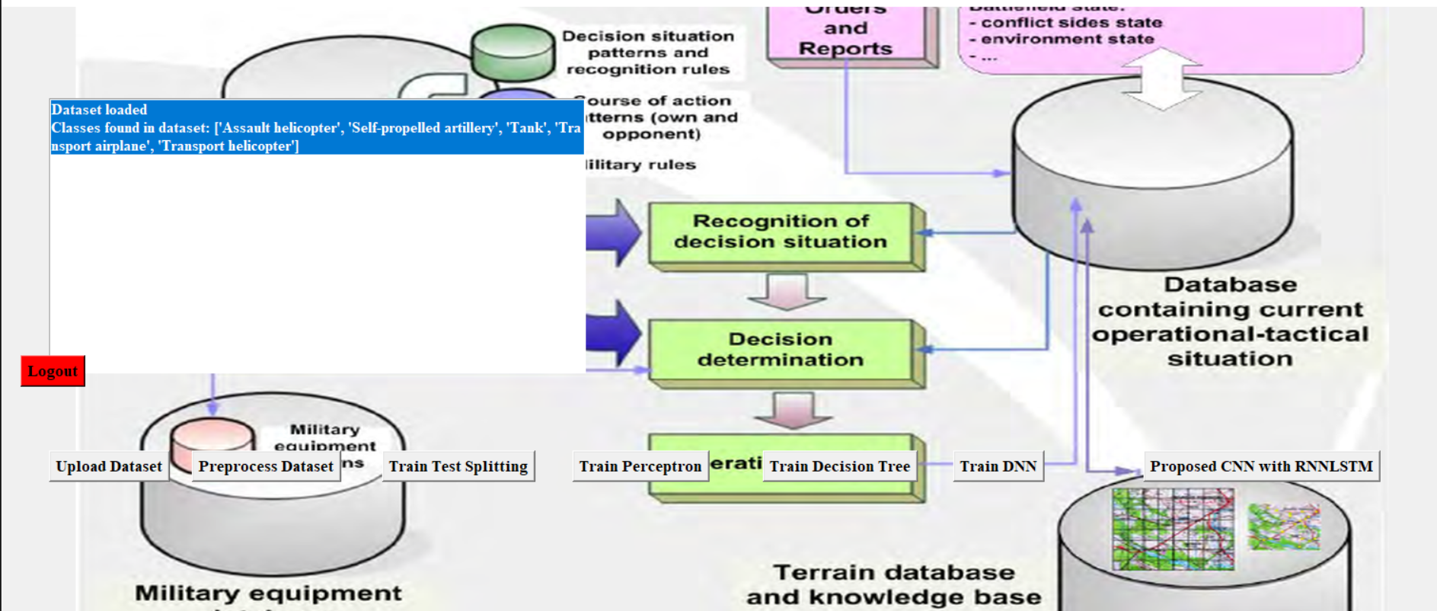
Figure 5.1: Dataset upload interface after admin login
The figure 5.1 illustrates the image preprocessing and train–test splitting stage of the military tactical decision support system after dataset upload. At this stage, all military equipment images are resized to a uniform dimension of 128 × 128 × 3, normalized, and converted into structured NumPy arrays. The interface displays confirmation messages indicating successful preprocessing along with the total number of samples allocated to the training dataset (6197 images) and testing dataset (1550 images).
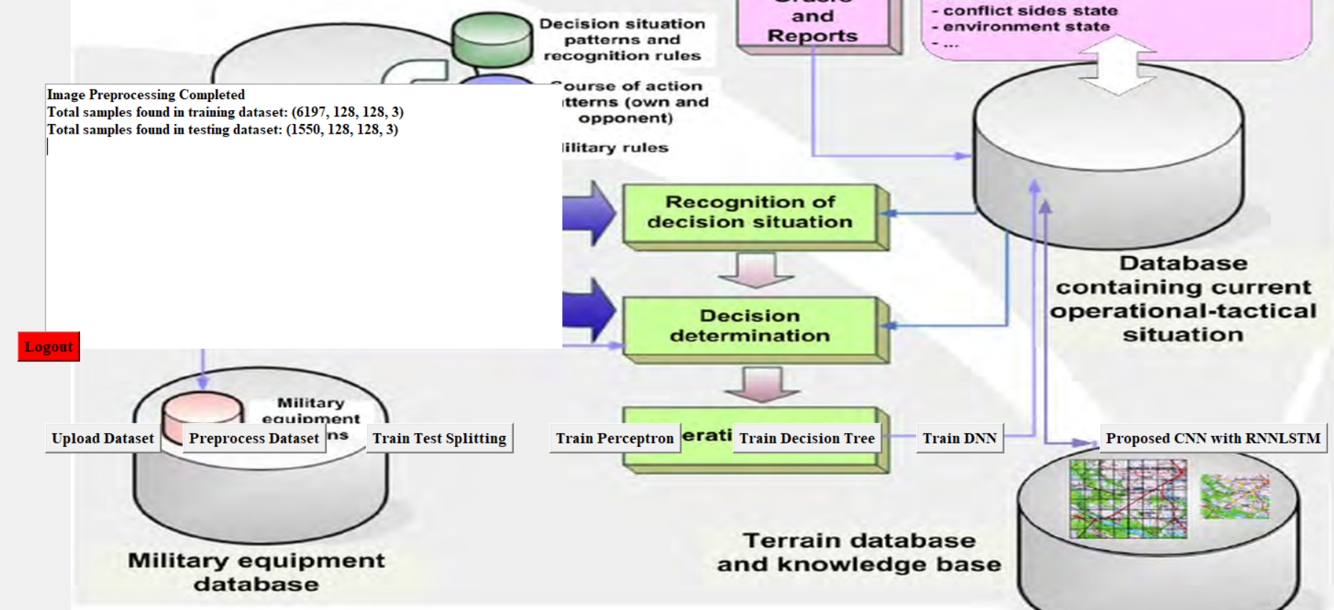
Figure 5.2: Data Preprocessing and splitting
5.4 Comparative analysis
The figure presents the confusion matrix of the existing Perceptron classifier applied to the military equipment image dataset. It shows that the Perceptron model exhibits significant misclassification across most classes, with correct predictions concentrated only in a few diagonal entries, such as Tank and Self-Propelled Artillery, while many samples are incorrectly predicted as other categories. The heavy off-diagonal values indicate the model’s inability to capture complex visual patterns present in military imagery due to its linear nature. This result highlights the limitations of traditional linear classifiers for image-based tactical decision support and justifies the need for more advanced deep learning models.

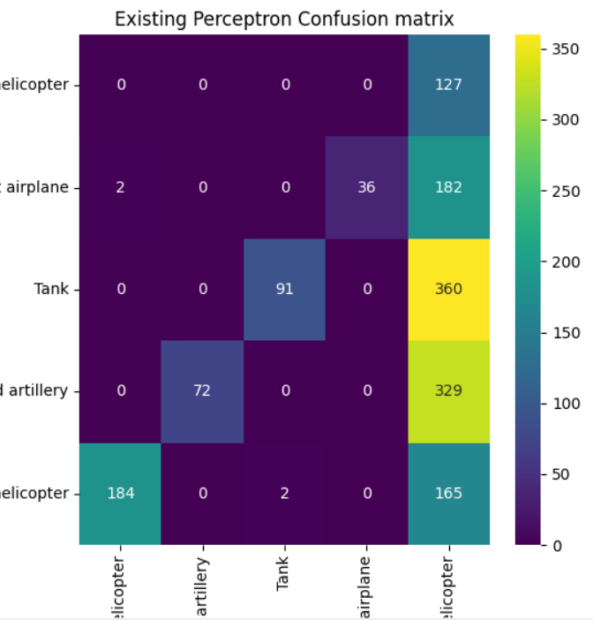
Figure 5.3: Confusion matrix obtained using perceptron model
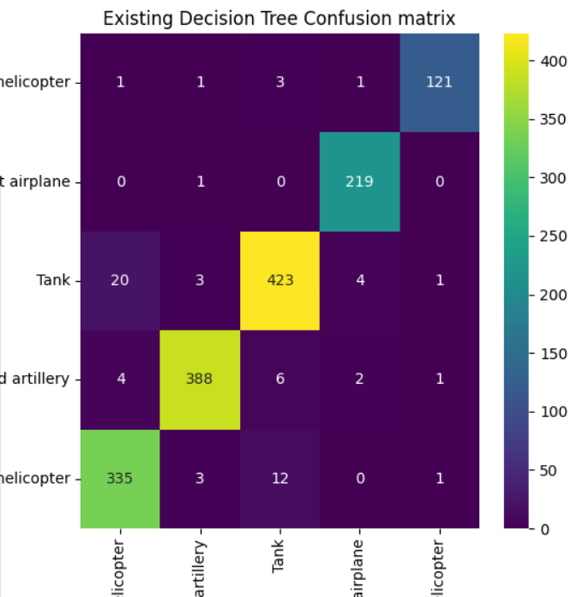
Figure 5.4: Confusion matrix obtained using Decision tree classifier
The figure 5.5 shows the confusion matrix of the existing Deep Neural Network (DNN) classifier applied to the military equipment image dataset. Compared to the Perceptron model, the DNN demonstrates a noticeable improvement in classification performance, with stronger diagonal values for classes such as Tank, Self-Propelled Artillery, and Transport Airplane, indicating better feature learning. However, misclassifications are still observed between visually similar categories, particularly among helicopter classes, due to limited spatial feature extraction in a fully connected network. This result indicates that while the DNN improves accuracy over linear models, it still lacks the robust spatial representation capability required for complex military image classification.
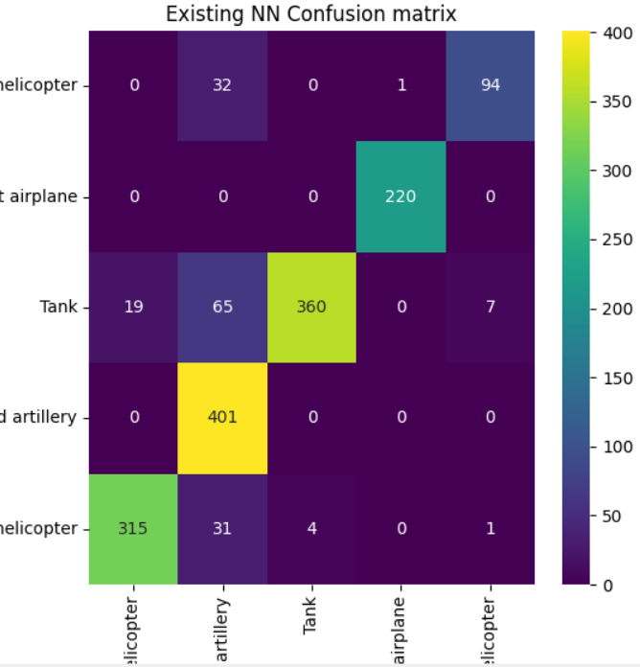
Figure 5.5: Confusion matrix obtained using DNN model
The figure 5.6 illustrates the confusion matrix of the proposed CNN with RNN (LSTM) model applied to the military equipment image dataset. The strong diagonal dominance indicates a significant improvement in classification accuracy, with classes such as Tank, Self-Propelled Artillery, and Transport Airplane being correctly classified with very high precision. Misclassifications are minimal and mainly occur between visually similar helicopter categories, which is expected due to overlapping visual features. Overall, this confusion matrix demonstrates that the proposed CNN–RNN model effectively captures both spatial and sequential features, outperforming existing Perceptron and DNN models and providing reliable support for tactical military decision-making.
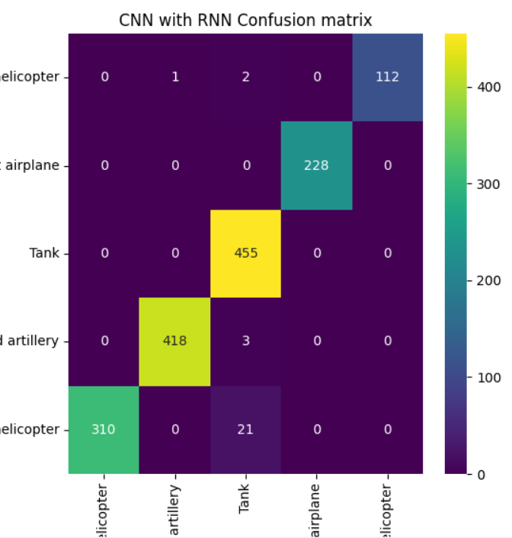
Figure 5.6: Confusion matrix obtained using Hybrid CNN with RNN Model
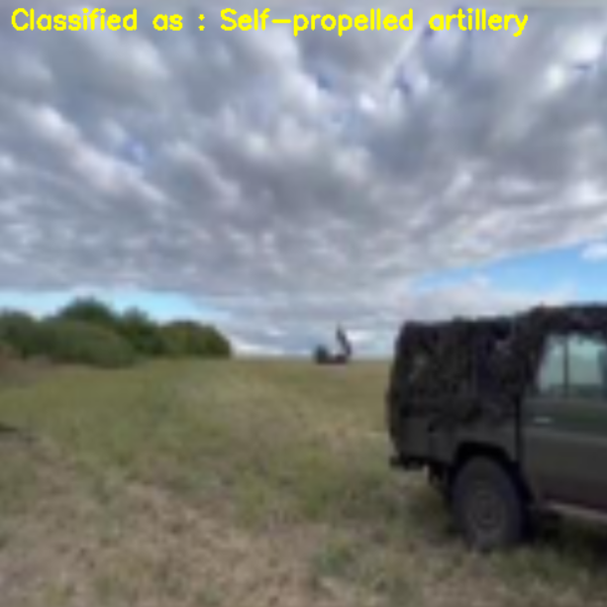
Figure 5.7: Prediction on test images obtained using hybrid CNN with RNN model
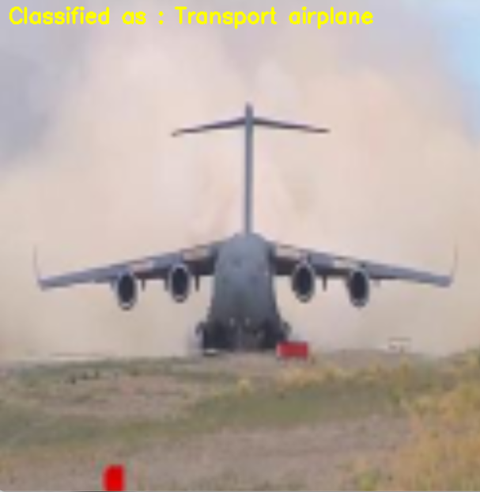
Figure 5.8: Prediction on test images obtained using hybrid CNN with RNN model
The figures 5.7 and 5.8 demonstrates the real-time prediction results obtained using the proposed CNN with RNN (LSTM) model on unseen test images from the military dataset. In the first example, the system correctly identifies a ground-based combat vehicle and overlays the label “Self-Propelled Artillery”, while in the second example, an aerial image is accurately classified as a “Transport Airplane.” These results highlight the model’s strong capability to extract discriminative spatial features through convolutional layers and effectively interpret contextual patterns using the RNN component. The clear and accurate overlay of predicted class labels on diverse test images confirms the robustness, generalization ability, and practical applicability of the proposed model for real-world military tactical decision support.
Table 1: Performance comparison for the Perceptron, DTC, DNN and Proposed CNN with RNN Model
Algorithms Name | Accuracy | Precision | Recall | F-score
Perceptron | 32.90% | 81.53% | 41.38% | 36.04%
DTC | 90.12% | 91.32% | 91.97% | 90.46%
DNN | 89.67% | 92.14% | 88.71% | 89.68%
CNN with RNN | 98.83% | 99.26% | 98.89% | 99.05%

Table 1 presents a detailed performance comparison of the Perceptron, Decision Tree Classifier (DTC), Deep Neural Network (DNN), and the proposed CNN with RNN model for military equipment image classification. The Perceptron model shows very poor overall performance with an accuracy of 32.90%, indicating its inability to handle high-dimensional image data, despite reporting a misleadingly high precision due to biased predictions. The Decision Tree Classifier achieves a strong improvement, attaining 90.12% accuracy, with balanced precision and recall values, demonstrating its effectiveness in modelling non-linear decision boundaries. The DNN further refines classification performance with 89.67% accuracy, benefiting from deeper feature learning but still lacking strong spatial feature extraction. In contrast, the proposed CNN with RNN model significantly outperforms all existing approaches, achieving an exceptional 98.83% accuracy, along with near-perfect precision, recall, and F-score values. This superior performance confirms the proposed model’s ability to effectively capture complex spatial and sequential patterns in military imagery, making it highly suitable for accurate and reliable tactical decision support.

6. VALIDATION

6. VALIDATION
The developed system is validated by testing it with different military equipment images from the dataset. The trained machine learning and deep learning models analyse the images and predict their respective categories. The prediction results are compared with the actual labels to measure accuracy. Performance evaluation metrics are used to confirm the reliability of the models. The validation results demonstrate that the system can successfully classify military equipment images and support tactical decision-making.
6.1 INTRODUCTION
Project validation is an important step used to verify whether the developed system works according to the expected objectives and requirements. It ensures that the system performs its functions correctly and produces accurate results. Validation helps confirm that the implemented algorithms and processes are reliable and effective for the intended application.
In this project, validation is performed by testing the machine learning models using different sets of image data. The dataset is divided into training and testing data to evaluate how well the models classify military equipment images. Performance metrics such as accuracy, precision, recall, and F1-score are used to measure the effectiveness of the system.
The validation process also ensures that the system provides consistent predictions when new images are uploaded. By analysing the performance results and visual outputs, it becomes possible to determine whether the system meets the goals of accurate military equipment classification and decision support.

6.2 Test Cases
TABLE 6.2.1 UPLOADING DATASET
Test Case ID | Test Scenario | Input | Expected Output | Actual Result | Status
TC01 | Upload image dataset | Military image dataset folder | Dataset should be successfully uploaded to the system | Dataset uploaded successfully | Pass
TC02 | Upload valid image files | JPG/PNG images | System should accept and store images | Images stored in dataset | Pass
TC03 | Upload invalid file format | Text or unsupported file | System should reject invalid files | Invalid file rejected | Pass
TC04 | Check dataset loading | Dataset with multiple images | Images should be loaded for preprocessing | Images loaded successfully | Pass
TC05 | Dataset preprocessing | Uploaded images | Images should be resized and normalized | Preprocessing completed | Pass

TABLE 6.2.2 CLASSIFICATION
Test Case ID | Test Scenario | Input | Expected Output | Actual Result | Status
TC06 | Upload image for classification | Military equipment image | System should accept the image | Image uploaded successfully | Pass
TC07 | Image preprocessing | Uploaded image | Image should be resized and converted to model format | Preprocessing successful | Pass
TC08 | Model prediction | Processed image | System should classify the image category | Correct category predicted | Pass
TC09 | Display prediction result | Classified image | Prediction result should be shown in GUI | Result displayed correctly | Pass
TC10 | Verify classification accuracy | Test image dataset | Model should correctly classify most images | Accurate predictions obtained | Pass

7. CONCLUSION &
FUTURE ASPECTS

7. CONCLUSION AND FUTURE ASPECTS
7.1 PROJECT CONCLUSION
The project successfully demonstrates the design and implementation of an intelligent Machine Learning–based Tactical Decision Support System for accurate classification of military equipment using image data. By leveraging a large-scale dataset consisting of five critical military categories such as Tank, Assault Helicopter, Self-Propelled Artillery, Transport Airplane, and Transport Helicopter the system effectively integrates image preprocessing, role-based authentication, and a GUI-driven workflow for end-to-end usability. A comprehensive comparative analysis was conducted using traditional machine learning models such as Perceptron and Decision Tree, a Deep Neural Network, and a proposed hybrid CNN with RNN architecture. Experimental results clearly show that while conventional models struggle with high-dimensional visual data, the proposed CNN–RNN model significantly outperforms all existing approaches, achieving superior accuracy, precision, recall, and F-score. The strong diagonal dominance in confusion matrices and highly accurate real-time predictions on unseen test images validate the robustness and generalization capability of the proposed method. The integration of model persistence, performance visualization, and real-time prediction within a secure Tkinter-based interface further enhances the practical applicability of the system. The work confirms that deep learning–driven visual intelligence, particularly hybrid CNN–RNN architectures, can provide reliable and efficient tactical decision support, making the system well-suited for real-world military surveillance, reconnaissance, and operational planning applications.
7.2 FUTURE ASPECTS
The tactical decision support system can be enhanced by integrating advanced deep learning architectures such as Efficient Net, Vision Transformers, or attention-based CNN models to further improve classification accuracy and robustness. The system can be extended to support real-time video stream analysis from drones or surveillance cameras for continuous battlefield monitoring. Incorporating multimodal data sources such as radar, infrared, and sensor data along with images can improve situational awareness. Additionally, deployment on real-world military operations.

8. BIBLIOGRAPHY

8. BIBLIOGRAPHY
8.1 REFERENCES
- Zigulic, N.; Glucina, M.; Lorencin, I.; Matika, D. Military Decision-Making Process Enhanced by Image Detection. Information 2024, 15, 11. https://doi.org/10.3390/info15010011
- Costa, J. P. A. Dantas, E. Scukins, F. L. L. Medeiros and P. Ögren, "Simulation and Machine Learning in Beyond Visual Range Air Combat: A Survey," in IEEE Access, vol. 13, pp. 76755-76774, 2025, doi: 10.1109/ACCESS.2025.3563811.
- Bistron, M.; Piotrowski, Z. Artificial Intelligence Applications in Military Systems and Their Influence on Sense of Security of Citizens. Electronics 2021, 10, 871. https://doi.org/10.3390/electronics10070871
- Galán, J.J.; Carrasco, R.A.; LaTorre, A. Military Applications of Machine Learning: A Bibliometric Perspective. Mathematics 2022, 10, 1397. https://doi.org/10.3390/math10091397
- Skarka, W.; Ashfaq, R. Hybrid Machine Learning and Reinforcement Learning Framework for Adaptive UAV Obstacle Avoidance. Aerospace 2024, 11, 870. https://doi.org/10.3390/aerospace11110870
- Alcántara Suárez, E.J.; Monzon Baeza, V. Evaluating the Role of Machine Learning in Defense Applications and Industry. Mach. Learn. Knowl. Extr. 2023, 5, 1557-1569. https://doi.org/10.3390/make5040078
- Cho, S.; Shin, W.; Kim, N.; Jeong, J.; In, H.P. Priority Determination to Apply Artificial Intelligence Technology in Military Intelligence Areas. Electronics 2020, 9, 2187. https://doi.org/10.3390/electronics9122187
- Karna, H.; Braović, M.; Gudelj, A.; Buličić, K. Artificial Intelligence-Based Prediction Model for Maritime Vessel Type Identification. Information 2025, 16, 367. https://doi.org/10.3390/info16050367
- Caballero-Martin, D.; Lopez-Guede, J.M.; Estevez, J.; Graña, M. Artificial Intelligence Applied to Drone Control: A State of the Art. Drones 2024, 8, 296. https://doi.org/10.3390/drones8070296
- Olugbade, S.; Ojo, S.; Imoize, A.L.; Isabona, J.; Alaba, M.O. A Review of Artificial Intelligence and Machine Learning for Incident Detectors in Road Transport Systems. Math. Comput. Appl. 2022, 27, 77. https://doi.org/10.3390/mca27050077
- Hamrouni, B.; Bourouis, A.; Korichi, A.; Brahmi, M. Explainable Ontology-Based Intelligent Decision Support System for Business Model Design and Sustainability. Sustainability 2021, 13, 9819. https://doi.org/10.3390/su13179819
- Mills, D.; Pudney, S.; Pevcin, P.; Dvorak, J. Evidence-Based Public Policy Decision-Making in Smart Cities: Does Extant Theory Support Achievement of City Sustainability Objectives? Sustainability 2022, 14, 3. https://doi.org/10.3390/su14010003
- Latif, S.; Driss, M.; Boulila, W.; Huma, Z.e.; Jamal, S.S.; Idrees, Z.; Ahmad, J. Deep Learning for the Industrial Internet of Things (IIoT): A Comprehensive Survey of Techniques, Implementation Frameworks, Potential Applications, and Future Directions. Sensors 2021, 21, 7518. https://doi.org/10.3390/s21227518
- Iftikhar, S.; Asim, M.; Zhang, Z.; Muthanna, A.; Chen, J.; El-Affendi, M.; Sedik, A.; Abd El-Latif, A.A. Target Detection and Recognition for Traffic Congestion in Smart Cities Using Deep Learning-Enabled UAVs: A Review and Analysis. Appl. Sci. 2023, 13, 3995. https://doi.org/10.3390/app13063995
- Mohan, P.V.; Dixit, S.; Gyaneshwar, A.; Chadha, U.; Srinivasan, K.; Seo, J.T. Leveraging Computational Intelligence Techniques for Defensive Deception: A Review, Recent Advances, Open Problems and Future Directions. Sensors 2022, 22, 2194. https://doi.org/10.3390/s22062194
- Reis, J.; Cohen, Y.; Melão, N.; Costa, J.; Jorge, D. High-Tech Defense Industries: Developing Autonomous Intelligent Systems. Appl. Sci. 2021, 11, 4920. https://doi.org/10.3390/app11114920

8.2 GITHUB LINK
https://github.com/meghanatuljaramGit/Major-Project-A12.git

